**Project Report Template**

**TITLE:BUILD AN EVENT MANAGEMENT SYSTEM USING SALESFORCE**

**1. INTRODUCTION**

* 1. **Overview**

Event management is the process creating and maintaining an event. This process spans from the very beginning of planning alla the way to post-event strategizing. At start, an event manager makes planning decisions, such as the time, location, and theme of therir event.

* 1. **Purpose**

The sole purpose of any event is that a group of people will convence in one particular purpose at a given time. Now that could be various purpose such as wedding, a business networking function, a church gathering, etc. All of which is to come together to explore that purpose.

**2. Problem Definition & Design Thinking**

**2.1 Empathy Map**

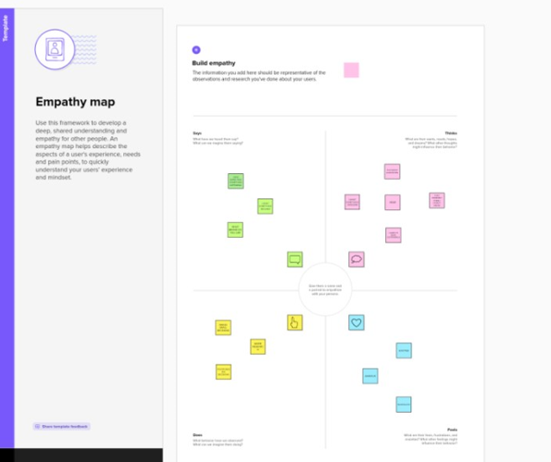

**2.2 Ideation & Brainstorming Map**

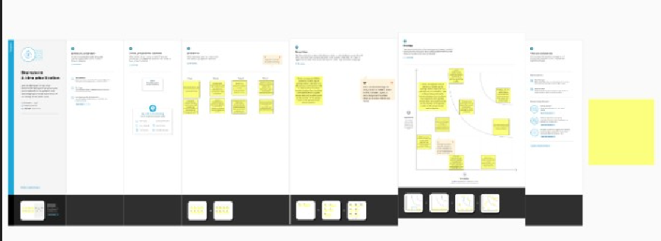

**3. RESULT**

**3.1 Data Model:**

|  |  |
| --- | --- |
| Object Name | Field in the Object |
| Obj - 1 | |  |  | | --- | --- | | Field Label | Data Type | | Enter bio | Text area | | Email | Email | |
| Obj - 2 | |  |  | | --- | --- | | Field Label | Data Type | | Phone | Phone | | Enter service provider | Text | |

**3.2 Activity & Screenshot**

**Milestone 1 - Salesforce?**

Salesforce is your customer success platform, designed to help you sell, service, market, analyze, and connect with your customers. Salesforce has everything you need to run your business from anywhere. Using standard products and features, you can manage relationships with prospects and customers, collaborate and engage with employees and partners, and store your data securely in the cloud.

**Milestone 2 – Object:**

What is an object?

Salesforce objects are database tables that permit you to store data that is specific to an organization. It consists of fields (columns) and records (rows).

Salesforce objects are of two types:

* Standard Objects: Standard objects are the kind of objects that are provided by salesforce.com such as users, contracts, reports, dashboards, etc.
* Custom Objects: Custom objects are those objects that are created by users. They supply information that is unique and essential to their organization. They are the heart of any application and provide a structure for sharing data.

**Milestone 3 – Tab:**

* **Tab**
* Tabs in Salesforce help users view the information at a glance. It displays the data of objects and other web content in the application.
* There are mainly 4 types of tabs:
* **Standard Object Tabs:**
* Standard object tabs display data related to standard objects.
* **Custom Object Tabs:**
* Custom object tabs display data related to custom objects. These tabs look and function just like standard tabs.
* **Web Tabs:**
* Web Tabs display any external Web-based application or Web page in a Salesforce tab.

.

**Milestone 4 – Fields:**

What are fields?

Fields in Salesforce represents what the columns represent in relational databases. It can store data values which are required for a particular object in a record.

There are 2 types of fields in salesforce:

* • Standard fields: There are four standard fields in every custom object that are Created By, Last Modified By, Owner, and the field created at the time of the creation of an object. These fields cannot be deleted or edited and they are always required. For standard objects, the fields which are present by default in them and cannot be deleted from standard objects are standard fields.
* • Custom fields: The Custom fields which are added by the administrator/developer to meet the business requirements of any organization. They may or may not be required

**Milestone 5 – Profile:**

What is a profile?

A profile is a group/collection of settings and permissions that define what a user can do in salesforce. A profile controls “Object permissions, Field permissions, User permissions, Tab settings, App settings, Apex class access, Visualforce page access, Page layouts, Record Types, Login hours & Login IP ranges.

* A profile can be assigned to many users, but user can be assigned single profile at a time.

**Milestone 6 – User:**

What is a user?

* A user is anyone who logs in to Salesforce. Users are employees at your company, such as sales reps, managers, and IT specialists, who need access to the company's records. Every user in Salesforce has a user account. The user account identifies the user, and the user account settings determine what features and records the user can access.

**Milestone 7 – Permission sets:**

* What is a permission set?
* A permission set is a collection of settings and permissions that give users access to various tools and functions. Permission sets extend users’ functional access without changing their profiles.
* Create permission sets to grant access among logical groupings of users, regardless of their primary job function. For example, let’s say you have several users who must delete and transfer leads. You can create a permission set based on the tasks that these users must perform and include the permission set within permission set groups based on job functions.

**Milestone 8 - Reports**

* Reports in Salesforce is a list of records that meet a particular criterion which gives an answer to a particular question. These records are displayed as a table that can be filtered or grouped based on any field.

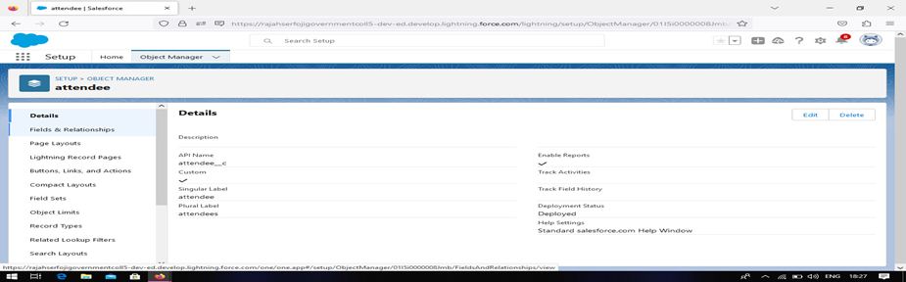

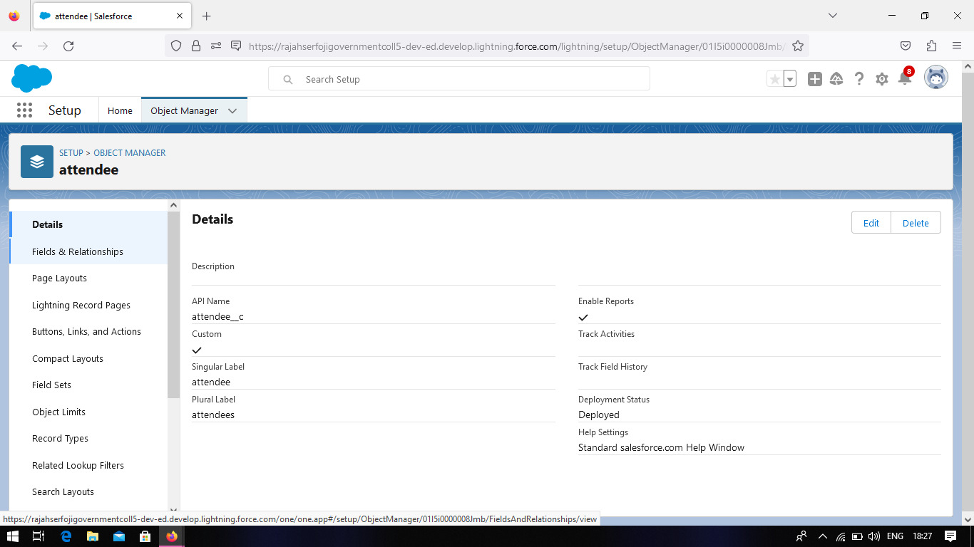

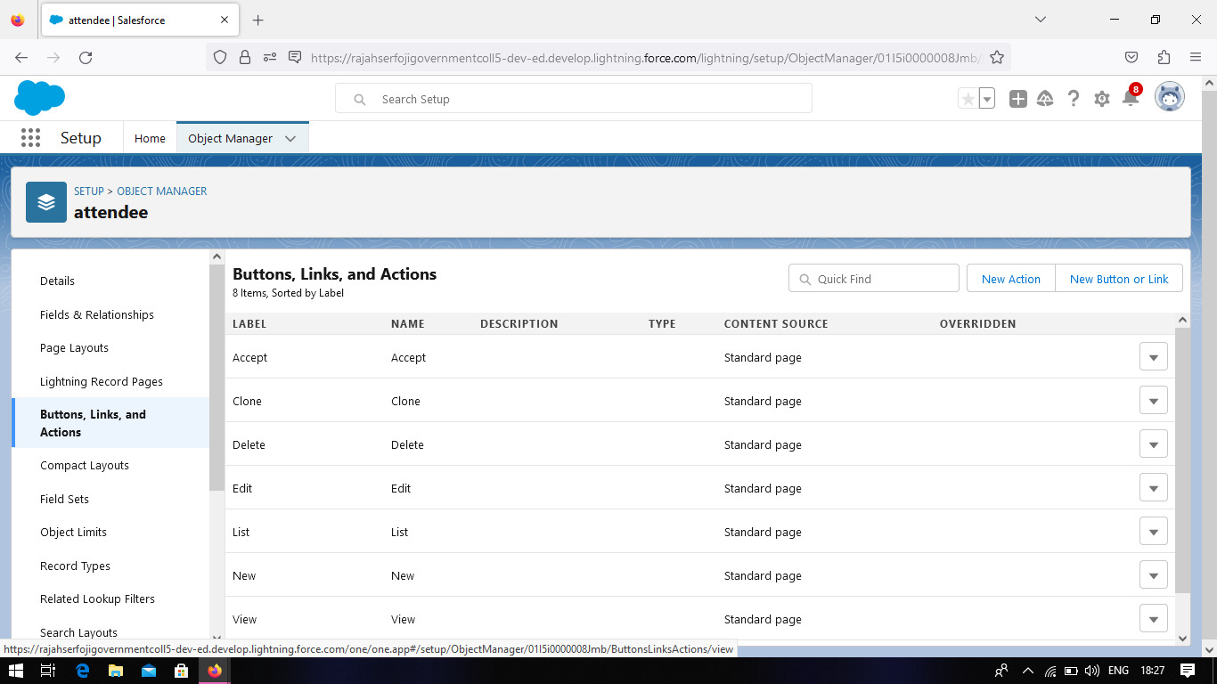

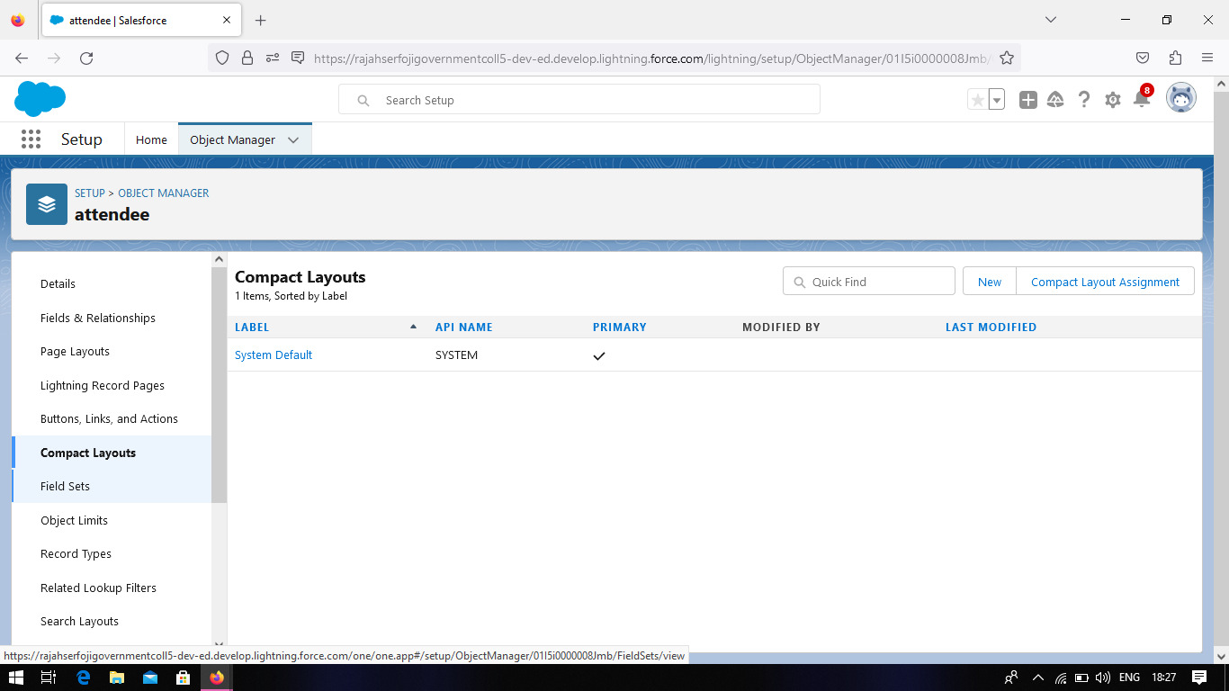

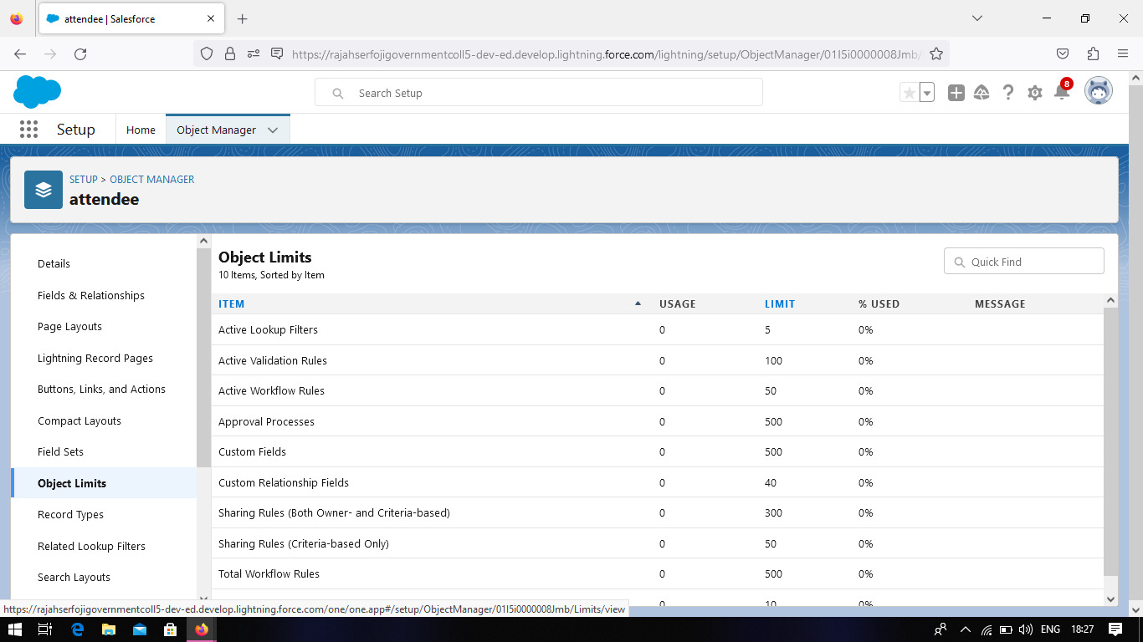

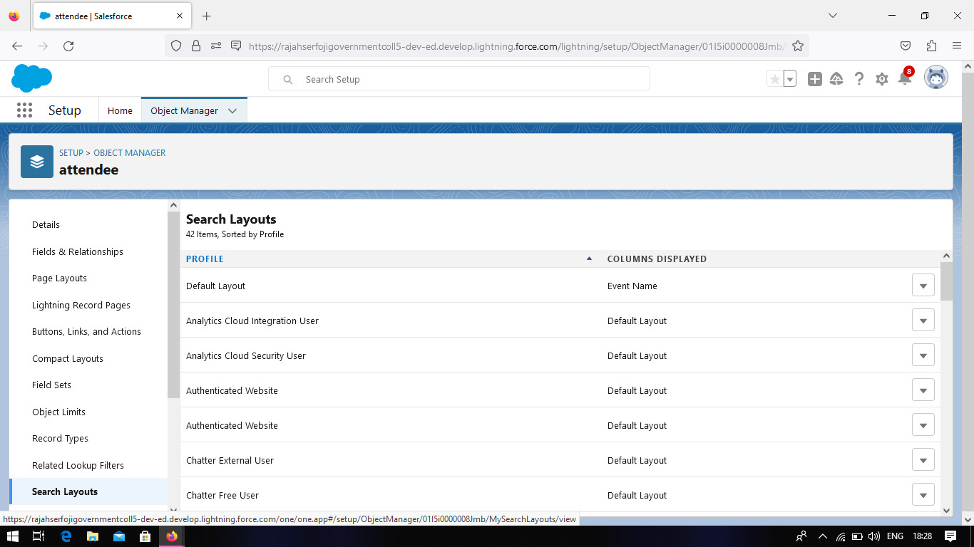

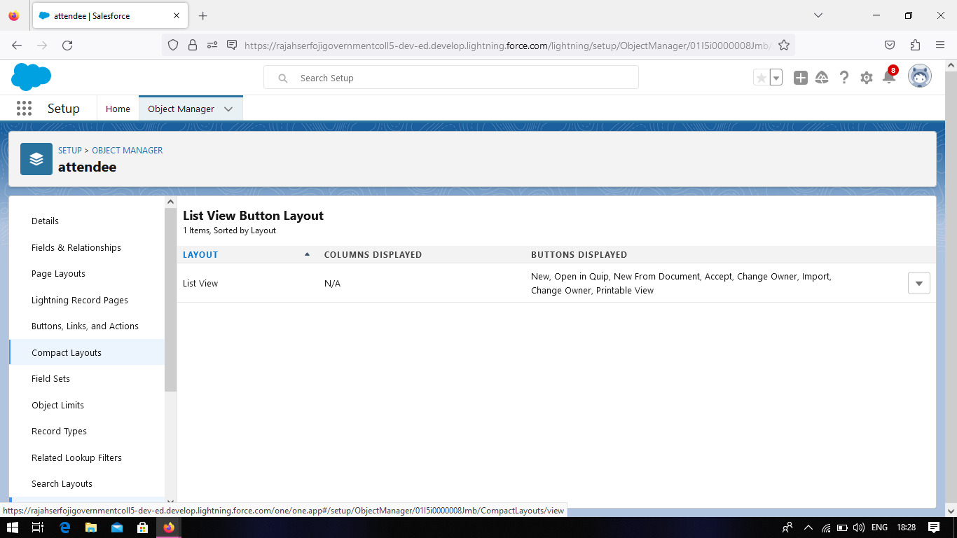

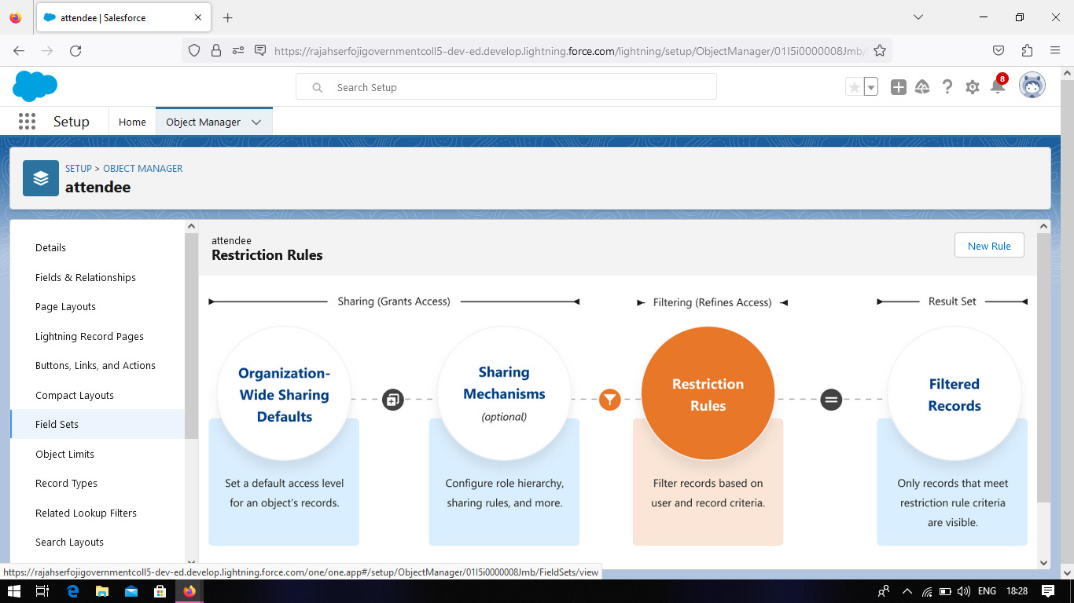

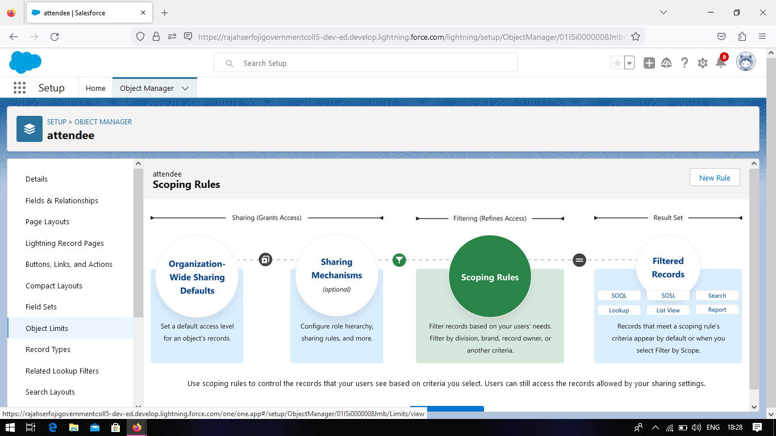

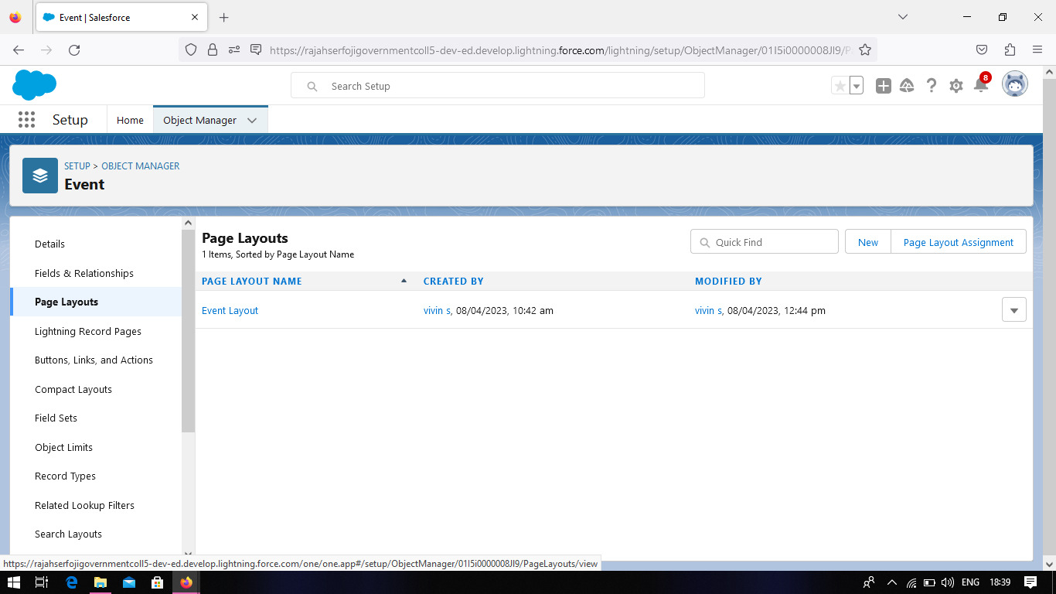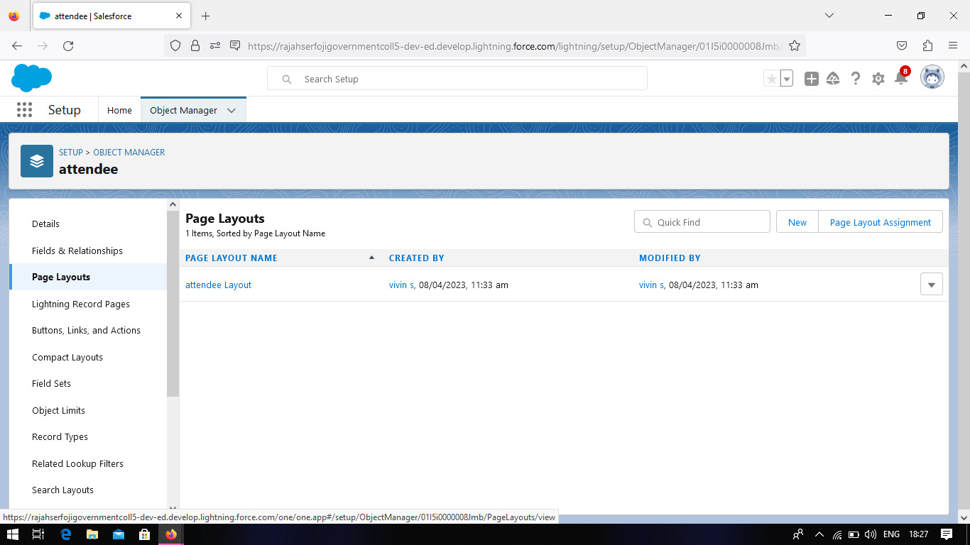

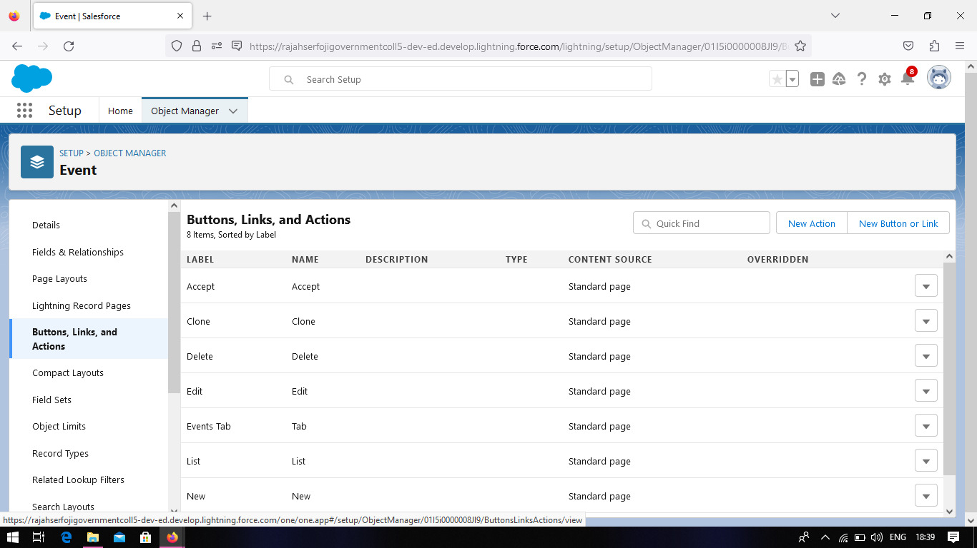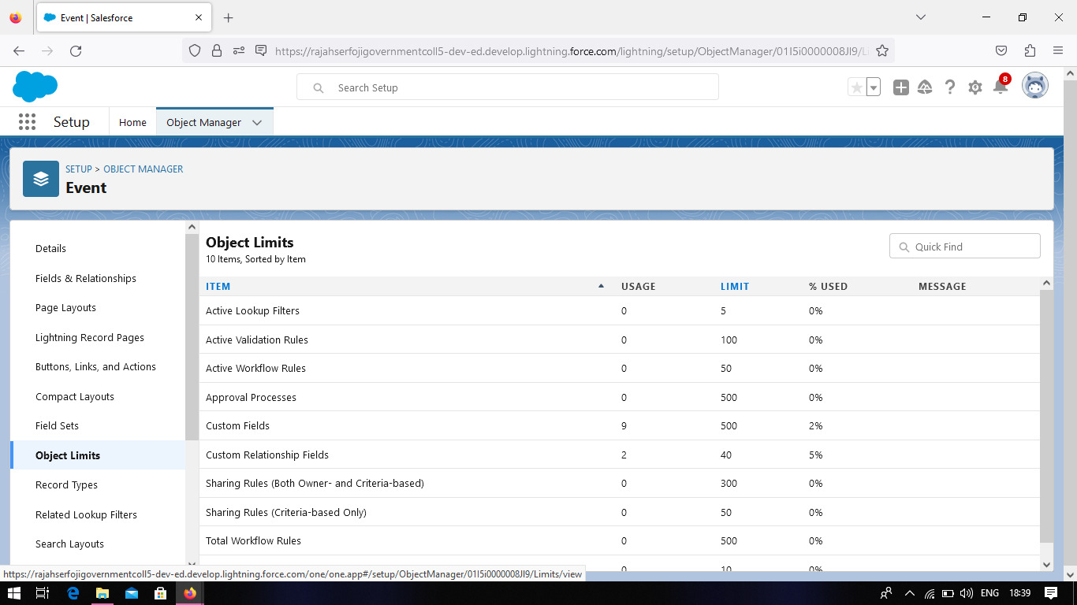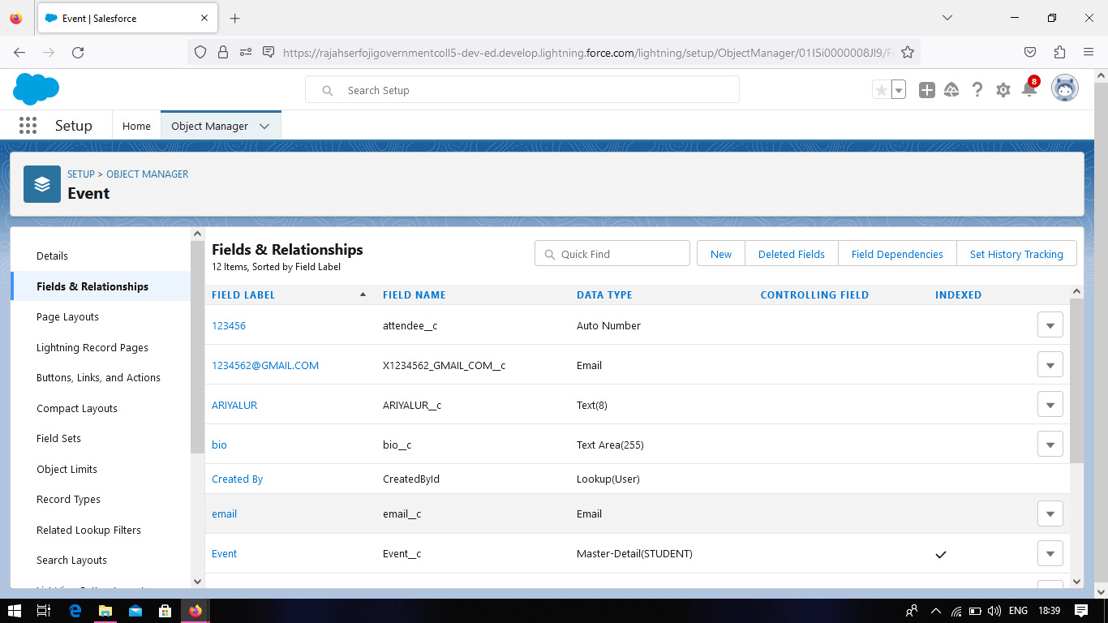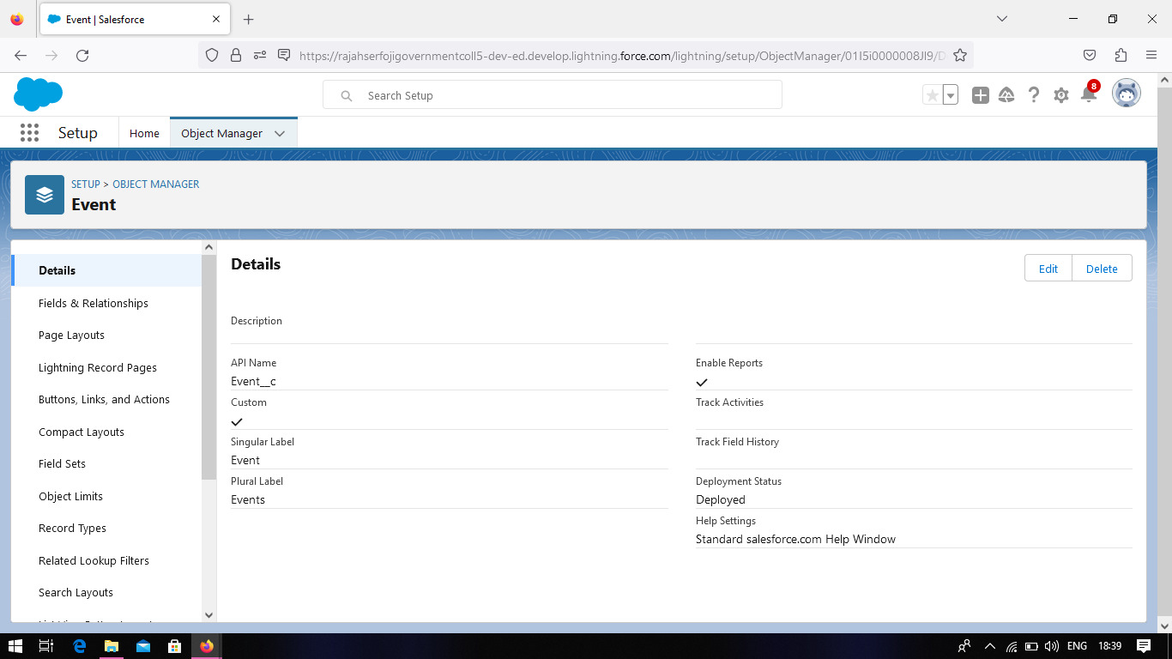

**4. Trailhead Profile Public URL**

Team Lead – 1. S.VIVIN - <https://trailblazer.me/id/vivis14>

Team Member 2. K.KARTHIKEYAN - <https://trailblazer.me/id/kartk97>

Team Member 3. M. VIJAYARAGHAVAN - <https://trailblazer.me/id/vragavan12>

Team Member 4.K. KANGATHARAN – <https://trailblazer.me/id/kangk7>

**5. ADVANTAGES & DISADVANTAGE**

**ADVANTAGES**:

1.Event experts

2.Save time and money

3.Creativity

4.Skilled teams

5.Meaurability

**DISADVANTAGES**

:

1.Unconventional work hours

2.Time away from family and friends

3.Experience requriement

4.Multiple event at same time

5.High level of responsibility

**6. APPLICATIONS**

Event management solution is a web application for EINS consultancy that allows users to manage events, announcements, and content of the websit. Management includes creation, deletion, update, and view. Both the system manager and administrator has privilege to manage events, announcement, and content of the website .

**7. CONCLUSION**

Event management system is user friendly and cost effective system, it is customized with activities related to event management life-cycle.

**8. FUTURE SCOPE**

Celebration and occasions are an important and integral part of human life. One or other day, there are some events going through every corner of globe. Some can be weddings, exhibitiobs, concerts, fairs, parties etc.

As there are millions of job profiles in thousands of business and if you choose yourself to be great event planner then you might have some guts to keep yourself into a creative and management world.